|  |  |  |
| --- | --- | --- |
| **Ex.No.2** | **Usage of Operators** | **Reg.No:** URK22CS1200 |
| **27.09.2022** |

# a)Write a program to demonstrate the usage of increment and decrement operators

## AIM:

To calculate the increment and decrement operators, using the formulae var1++, ++var2, var1--, --var2

## ALGORITHM:

Step 1: Start the program.

Step 2: Declare the required variable a and b. Step 3: Read the input values as var1 and var2. Step 4: Compute var1++, ++var2, var1--, --var2 Step 5: Display "%d\n",var1++

"%d\n",++var2 "%d\n",var1--

"%d\n",--var2 Step 6: Stop the Program.

## PROGRAM:

#include<stdio.h> void main()

{

int var1=3,var2=6; printf("%d\n",var1++); printf("%d\n",++var2); printf("%d\n",var1--);

printf("%d\n",--var2);

}

# OUTPUT:

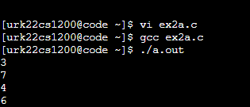

**Result:**

This program is executed successfully and the increment and decrement operator is displayed on the screen

|  |  |  |
| --- | --- | --- |
| **Ex.No.2** | **Usage of Operators** | **Reg.No:** URK22CS1200 |
| **27.09.2022** |

**b)Write a program to demonstrate the usage of bitwise operators.**

## AIM:

To calculate the bitwise operations using the formulae a&b, a|b, a^b, ~a, ~b, a>>b, b>>1, a<<1, b<<1.

## ALGORITHM:

Step1: start the program.

Step2: declare the required variable a and b. step 3: read the input as a and b.

Step 4: compute a&b, a|b, a^b, ~a, ~b, a>>b, b>>1, a<<1, b<<1 Step 5: display “%d \n” for every terms

Step 6: stop the program.

## PROGRAM:

#include<stdio.h> void main()

{

int a=10, b=7;

printf("the output of the bitwise AND operator is %d\n",a&b); printf("the output of the bitwise OR operatior is %d\n",a/b); printf("the output of the bitwise EXOR operator is %d\n",a^b); printf("the output of the bitwise NOT operator is %d\n",~a); printf("the output of the bitwise NOT operator is %d\n",~b); printf("the output of the bitwise Right shift operator is %d\n",a>>1); printf("the output of the bitwise Right shift operator is %d\n",b>>1); printf("the output of the bitwise Left shift operator is %d\n",a<<1); printf("the output of the bitwise Left shift operator is %d\n",b<<1);

}

# OUTPUT:

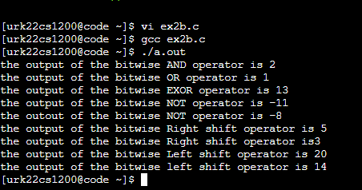

**Result:**

This program is executed successfully and the bitwise operators is displayed on the screen.

|  |  |  |
| --- | --- | --- |
| **Ex.No.2** | **Usage of Operators** | **Reg.No:** URK22CS1200 |
| **27.09.2022** |

**c)Write a program to evaluate the expression 17 - 8 / 4 * 2 + 3 - ++a (a=5). Explain the steps to achieve the result.**

## AIM:

To calculate the expression using the add, sub, mul and div

## ALGORITHM:

Step 1: start the program.

Step 2: declare the variables a and b. Step 3: read the input values of a and b.

Step 4: compute : b=17 - 8 / 4 * 2 + 3 - ++a (a=5). Step 5: display “%d”, b

Step 6: stop the program.

## PROGRAM:

#include <stdio.h> int main() {

int a=5,b;

b=17-8/4*2+3-++a;

printf("The answer is %d", b); return 0;

}

## OUTPUT:

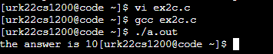

**Result :**

The given program has been executed successfully and the output for the expression (17 - 8 / 4 * 2 + 3 - ++a ) is displayed on the screen

|  |  |  |
| --- | --- | --- |
| **Ex.No.2** | **Usage of Operators** | **Reg.No:** URK22CS1200 |
| **27.09.2022** |

# d)Write a program to read the body temperature and print whether a person has fever or not using conditional operator.

## AIM:

To calculate the body temperature using the conditional operator (temp >= 98.6) ?

**ALGORITHM:**

Step 1: start the program.

Step 2: declare the required variable a Step 3: read the inputs values as a Step 4: compute : temp >= 98.6

Step 5: display “%f”, &temp Step 6: stop the program.

## PROGRAM:

#include<stdio.h> void main()

{

float tem;

printf("enter your temperature(in fahrenheit):"); scanf("%f",&tem);

(tem>=98.6)?printf("you have fever!!"):printf("you donot have fever!!");

}

## OUTPUT:

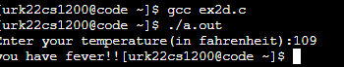

**Result:**

This program has been executed successfully and the person has fever or not is displayed on the screen.

|  |  |  |
| --- | --- | --- |
| **Ex.No.2** | **Usage of Operators** | **Reg.No:** URK22CS1200 |
| **27.09.2022** |

# e)Write a program to print the result of a student as per the following condition: a student is declared pass if he scores 50 marks and above in all subjects (Take 3 subjects) and declared to be fail otherwise (use AND operator)

## AIM:

To calculate the marks of the student using the formulae (sub1 >= 50 && sub2 >= 50 && sub3 >= 50)?

## ALGORITHM:

Step 1: Start the program.

Step 2: Declare the required variables sub1, sub2 and sub3 Step 3: Read the inputs values as sub1, sub2 and sub3

Step 4: Compute : sub1 >= 50 && sub2 >= 50 && sub3 >= 50 Step 5: Display “%d”

Step 6: Stop the program.

## PROGRAM:

#include<stdio.h> void main()

{

int sub1,sub2,sub3; printf("enter subject 1 marks:"); scanf("%d",&sub1); printf("enter subject 2 marks:"); scanf("%d",&sub2); printf("enter subject 3 marks:"); scanf("%d",&sub3);

(sub1>=50&&sub2>=50&&sub3>=50)?printf("you passed the exam!!"):printf("you failed in the exam!!");

}

## OUTPUT:

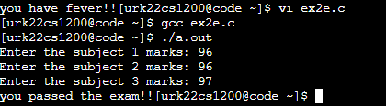

**Result:**

The program has been executed successfully and the student passed is displayed on the screen.

|  |  |  |
| --- | --- | --- |
| **Ex.No.2** | **Usage of Operators** | **Reg.No:** URK22CS1200 |
| **27.09.2022** |

# f)Write a program to print result of the division as per the following condition: the number is divisible if the denominator is not to be zero and the modulus of the two numbers must be zero. Otherwise declare the number is not divisible. (use AND operator)

## AIM:

To calculate the numerator and denominator using the formulae (deno!=0&&nume%deno==0)?

## ALGORITHM:

Step 1: Start the program.

Step 2: Declare the required variables as nume and deno Step 3: Read the inputs values as nume and deno

Step 4: Compute the (deno!=0&&nume%deno==0)? Step 5: Display “%d”

Step 6: Stop the program.

## PROGRAM:

#include<stdio.h> void main()

{

int nume,deno;

printf("enter numerator value:"); scanf("%d",&nume);

printf("enter denomenator value:"); scanf("%d",&deno);

(deno!=0&&nume%deno==0)?printf("the no is divisible"):printf("the no is not divisible");

}

## OUTPUT:

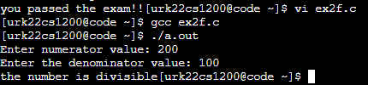

**Result:**

The program has been executed successfully and whether the number is divisible or indivisible is displayed on the screen.